ANSHIKA SRIVASTAVA

SAP ID – 500107049

BATCH – B1 HONS.

LAB EXPERIMENT - 1

Q1) Write a Python program to perform basic arithmetic operations (addition, subtraction, multiplication, division, and modulus) on two numbers.

Prompt the user to enter two numbers.

Perform the arithmetic operations and print the results. (Use appropriate operators and print formatting for clear output.)

**Code –**

num1 = float(input("Enter the first number "))

num2 = float(input ("Enter the second number "))

print("Addition of two numbers",num1 + num2)

print("Subtraction of two numbers",num1 - num2)

print("Multiplication of two numbers",num1 * num2)

print("Division of two numbers",num1 / num2)

print("Modulus of two numbers",num1 % num2)

Output –

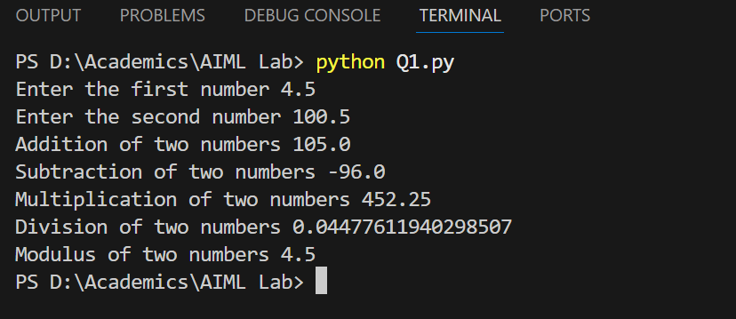

Q2) Create variables of different data types (integer, float, string, boolean) and perform basic operations on them.

Assign values to variables of different data types.

Perform arithmetic operations on numeric data types.

Concatenate strings using + operator.

Use logical operators to evaluate boolean expressions

**Code –**

integer = int(input("Enter the integer number "))

float = float(input("Enter the float number "))

string = input("Enter the string ")

boolean = bool(input("Enter the boolean value "))

print("Addition of two numbers",integer + float)

print("Subtraction of two numbers",integer - float)

print("Multiplication of two numbers",integer * float)

print("Division of two numbers",integer / float)

print("Modulus of two numbers",integer % float)

print(string + " from Anshika\n") #concatenation

#logical operators

print("AND operation",boolean and True)

print("OR operation",boolean and True)

print("NOT operation",not boolean)

Output –

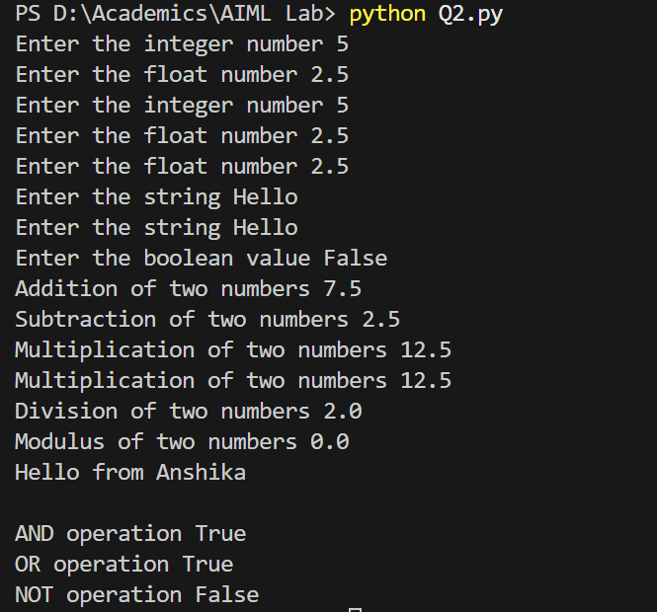

Q3) Write a program to take user input, process it, and display the result. Prompt the user to enter their name. Greet the user using their name.

Calculate and print the user's age based on their birth year.

**Code –**

name = input("Enter your name here ")

greet = f"Greetings, {name} Nice to meet you!"

print(greet)

dob = int(input("Enter your year of birth "))

print("Current age is",2025 - dob)

Output –

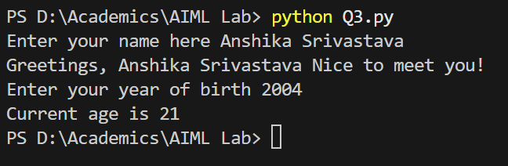

Q4) Write a program to check if a number is even is odd. Prompt the user to enter a number. Use the modulus operator to determine if number is even or odd.

**Code –**

num = int(input("Enter a number "))

if(num % 2 == 0):

print("Number is even")

else:

print("Number is odd")

Output –

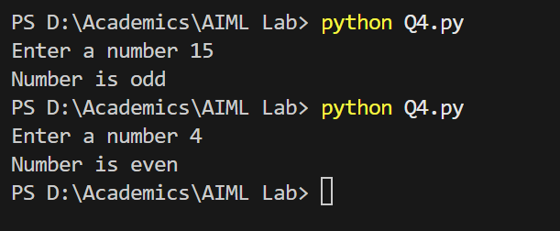

Q5) Write a program to print the numbers from 1 to 10 using both for and while loops.

Use a for loop to iterate through a range of numbers.

Use a while loop with a counter variable.

**Code –**

print("Using for loop")

for i in range(1,11):

print(i)

print("Using while loop")

counter=0

while(counter<=10):

print(counter)

counter+=1

Output –

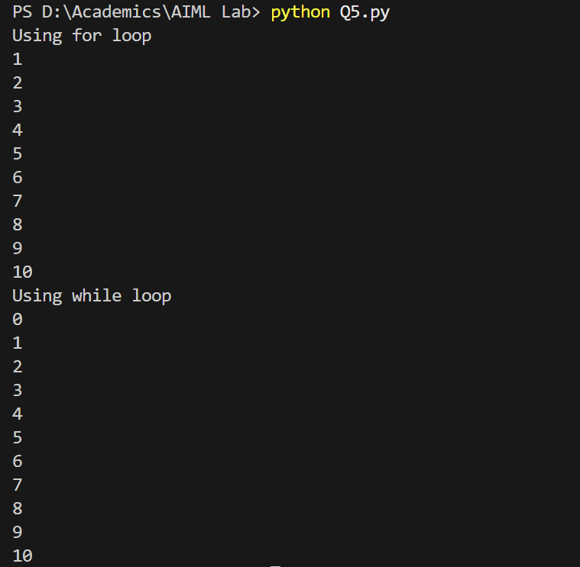

Q6) Create a list, access elements, modify elements, and perform list operations.

Create a list of fruits.

Access elements using indexing.

Modify elements in the list.

Add and remove elements from the list.

Find the length of the list.

Sort the list in ascending and descending order.

**Code –**

fruits = ["Strawberry", "Guava", "Cherry", "Apple", "Orange", "Banana"]

print("Accessing elements using indexing ")

print("First fruit is ",fruits[0])

print("Third fruit is ",fruits[2])

print("\n Modifying element in the list")

fruits[3] = "Watermelon"

print("Modified list is ",fruits)

print("\n Adding and removing from list")

fruits.append("Mango")

fruits.remove("Orange")

print("Modified list is ",fruits)

print("\n Length of list is ",len(fruits))

print("\n Sorted list in ascending order is ",sorted(fruits))

print("\n Sorted list in descending order is ",sorted(fruits, reverse=True))

Output –

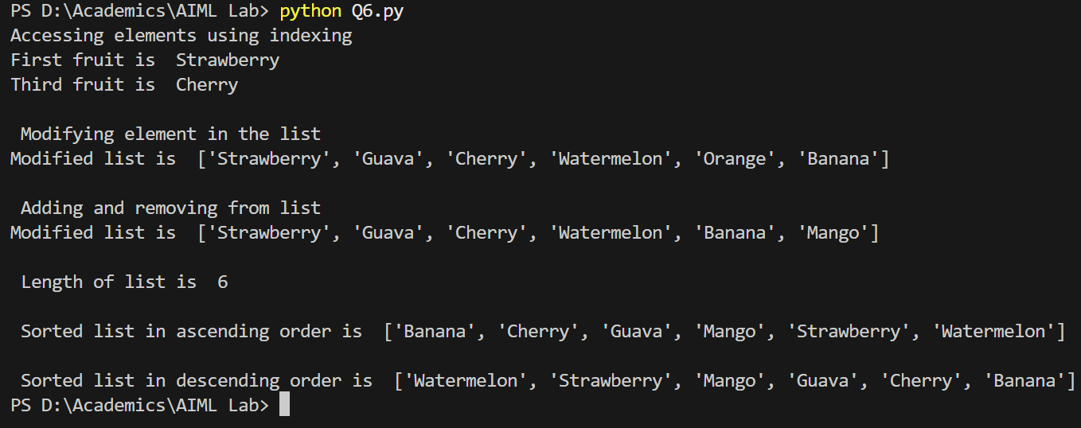

Q7) Manipulate strings using various built-in functions.

Create a string variable and find length of the string.

Convert string to uppercase and lowercase.

Check if a substring exists in the string.

Split the string into a list of words.

**Code –**

str = "Anshika is practicing python programming"

print("Length of the string is ",len(str))

print("String in uppercase is ",str.upper())

print("String in lowercase is ",str.lower())

substring = "python"

print("Substring in given string ",substring in str)

print("Splitting string in words ",str.split())

Output –

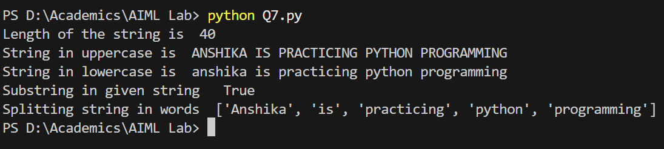

Q8) Write a program to find largest and smallest number in a list.

**Code –**

list = [75, 80, -4, 332, 23, 0, 2.1, 90]

list = sorted(list)

print("Smallest number is",list[0])

print("Largest number is",list[len(list)-1])

Output –

